Specification: Graphical User Interface (GUI) for STM32 motor controller
- Introduction
A set of two BLDC motors is by controlled by a PID motor controller on a STM32 board for an application. Currently, the target speed of motor 1.1 and motor 1.2 and cycle time are programmed in the software code.
The settings for target speed and cycle time need to be changed within ca. 30 seconds for the application to find the correct settings for testing. Therefore, an HMI is required for fast changing of controller settings.
For flexibility, the GUI should be displayed on a PC based touch screen and have wireless Bluetooth connection with the motor controller.

- Platform
  - Controller board (STM32, for example NUCLEO-F746ZG in combination with Bluetooth expansion board X-NUCLEO-67W61M1)
  - PC based touch screen (Android, Linux and Windows)
  - Web based Gui (Mongoose or similar)

- Software requirements for the GUI and STM32 board
- Display on the GUI of
  - Actual target speed setting motor 1.1
  - Actual target speed setting motor 1.2
  - Actual cycle time setting
  - Cumulative rotations motor 1.1, overwrite at start of next cycle
  - Cumulative rotations motor 1.2, overwrite at start of next cycle
  - Elapsed cycle time of motor 1.1, overwrite at start of next cycle
  - Elapsed cycle time of motor 1.2, overwrite at start of next cycle
- Change setting via the GUI of
  - Target speed motor 1.1
  - Target speed motor 1.2
  - Cycle time
- Buttons
  - Momentary start button: cycle time = time set in code of STM32 board
  - Momentary stop button: cycle stop (manual, stops cycle time set in code of STM32 board)
  - Momentary start button: cycle time = time the button is pressed

- Modularity
  - In the future plug & play expandable to 4 sets of BLDC motors
  - Scenario 1: Each set of BLDC motors has its own PID motor controller board with its own Bluetooth communication to the central PC based touch screen with the web based GUI, see picture below
  - Scenario 2: All 4 sets of BLDC motors share one controller board with one Bluetooth communication to the central PC based touch screen with the web based GUI, see picture below
  - To be discussed: which scenario to choose based on e.g.
    - Flexibility
    - Modularity
    - Ease of use
    - Size
    - Cost
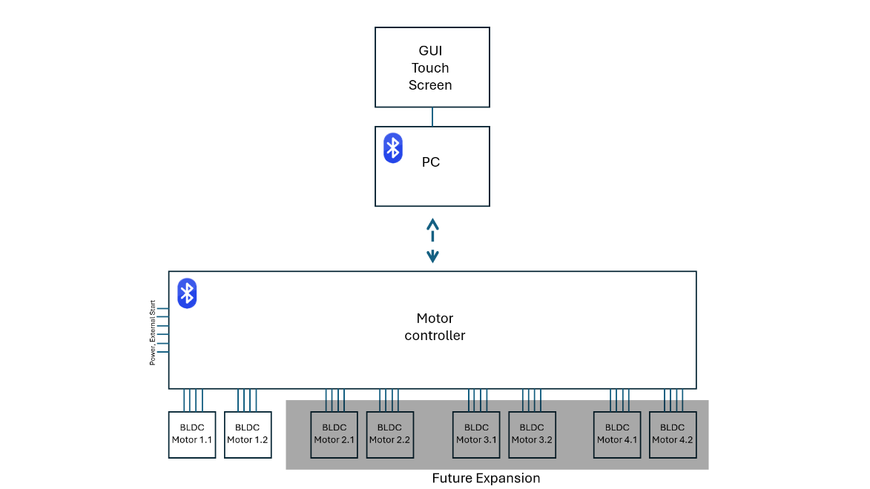
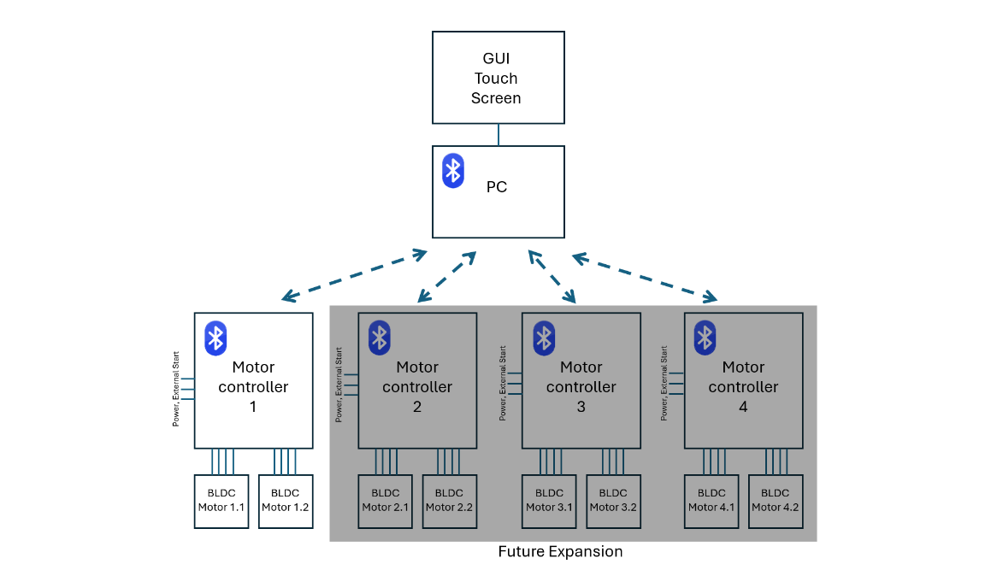

Scenario 2
Scenario 1

- Required scope of delivery
- Functional software for a PC based touch screen GUI and the STM32 boards as described above
- Software suitable for
  - uploading via STM32CubeIDE version 1.17.0 by us to our own STM32 board
  - installing on our own Windows PC

